Proposal

Domino’s School Lunch

Web Application

Alessandra Diniz

Amandeep Kour

Maryna Haidashevska

Monika Obireddt

Nguyen Truong

Wilmer Almazan

Zohaib Ali

**Executive Summary**

Our team Dynamic Developers has prepared proposal for your company Domino’s, Since Domino’s has more than billion customers all over the country. To improve fundraising for school’s lunch program, your company are going to provide a new website for school’s lunch program manager.

Dynamic Developers is a perfect team of our company located in Winnipeg, Manitoba for your project. Dynamic Developers posses all the skills and experienced for development of your company’s website.

To effectively capture your target market, we propose a key design and functionality aspects to website that will have immediate and long-term impact on your brand. The Dynamic Developer will create a website for your business that will have:

* Sales Improvement
* Separate Admin panel for school’s program managers
* Able to book date and menu for lunch
* Lunch menu list
* Registration for students/parents
* Pay online
* Boost your brand identity

In the following pages, we have included database design, mock up design for your websites, how it will look etc.

Sincerely

Dynamic Developers

### 

### Table of Contents

Page #

1. Background 3
2. Assumptions 3
3. Goals and Objectives 3
4. Scope of Work 3
5. Target Audience 4
6. Qualification 4
7. Business Scenario 5
8. Work Plan 5
9. Budget 6
10. General Requirements 7
11. Application Security Requirements 7
12. Server Setup Description 8
13. Server Security Description 8
14. Workback 9
15. Invoice 11
16. ERD(Conceptual, Logical, Physical) 12
17. Use Case Diagram 15
18. Wireframe 16
19. Mockup Designs 18

1. **Background**

Domino’s Pizza is an American multinational pizza restaurant chain founded in 1960 and one of the top Pizza Restaurant in Canada. In February 2018, the chain become the largest pizza seller worldwide in terms of sales. Domino’s requested for web development service for the new website which will be used by lunch program managers to reserve their school lunch dates and to allow parents/students to select available menu items and pay online. Main audience of the new website will be parents/students and school’s lunch program manager as administrator.

1. **Assumptions:**

* Upon approval of this proposal, the clients will provide all the content text and materials, logos, color, font guidelines etc. to be used at the new website.
* Domino’s will provide list of restaurants and their addresses and complete lunch program menu with prices, images and details.

1. **Goals and objectives:**

* Provide a platform to allow schools manage their pizza lunch events.
* Schools can mark up the cost of the menu items to offer.
* Parents/students
* Parents can choose how many items they want to order, according to all orders schools can calculate the total profit for themselves.
* Currently, this process is manual. The company wants to automate this process and create a new website.

1. **Scope of work:**

Domino emphasized their expectations for the new website:

* Website matches to modern standards
* Should contain company’s logo and similar fonts with parent’s site (Domino)
* Allows lunch program coordinators to plan their school lunch dates
* Has an option to select available items
* Option to invite parents/students
* Options for parents to pay for their order
* Must be functional, usable and easy-navigated
* Launch

1. **Target Audience:**

Primary Audience:

The primary target audience of the Dominos website are parents and school administration. The main objective of this website is to attract the schools to book their lunches through online system. Every store can book only 2 order a day. The school will send the token to respective parents. By using the token, they can select the lunch through provided menu. After selecting the menu, the payment will be done through online. School will charge some commission through payment. The dominos will receive the order by class number.

Secondary audience:

The secondary audience of this project will be children. They are not directly using the website, but they will affect the decisions of parents to decide the lunches from dominos website. Children diet will also affect the decisions.

1. **Qualifications**

Dynamic Developers is a well-known IT company in a market. Dynamic developers have an experience of working with number of companies.

We have qualified professional team members. All the them having qualified experience of more than 5-year experience. We have an experience of working with small and medium size websites of different companies in a market. Each team members have their own portfolio, and the following reflects the field of expertise in respective domain.

List of Team Members

|  |  |
| --- | --- |
| Wilmer Almazan | Project manager. Web-Developer and Network Engineer. 10 years of experience as project manager developing several IT projects. Responsible for server setup and security implementation. |
| Alessandra Diniz | Wide experience as project manager, database administrator and software developer. Se will be in charge of the database design and implementation. |
| Zohaib Ali | Programmer. 3 years experience as Computer Science Engineer. He will be in charge of code validation, testing and debugging. |
| Amandeep Kour | Programmer. Front end design and coding. |
| Monica Obireddy | Web developer. 2 years experience. Wide experience with CSS, HTML, JavaScript, jQuery and VueJS. Front end design manager. |
| Marina Haidashesvka. | Web Developer and Business Analyst. |
| Nguyen Truong | Programmer lead. Wide experience en e-commerce environment. |

1. ***Business Scenario:***

Data will be related to the menu, list of dominos and calendar. Menu data will be provided by dominos. Calendar will be used for advance booking. Booking should be done before delivery. School administration will select the nearest dominos from the dominos list.

Unauthenticated users should be to see the Registration, description related to menu’s and information related to the nearest dominos.

Authenticated users will be available to see the profile, receipt, edit option and cancellation. Authenticated users will get updates about delivery after placing the order. Remembrance email will be sent to both school and parents one day before deliver date.

Administrator can add, delete and update information related to the order before specific date. Administrator will able to see the information related to the users like log file.

1. **General Requirements:**

* Product scalability with a good database design
* Easy to use and clear navigation of the site
* Redesign website with the same branding for a new look and feel
* Real time scheduling of events
* Good usability for school and parents to order lunch
* Simple admin interface to make things easier
* Token assignment system to uniquely identify school
* Reliable registration process to facilitate correct delivery of orders
* Mail server set up for sending confirmation emails
* Payment gateway API for order transactions

1. **Application Security Requirements:**

|  |  |
| --- | --- |
| Cross Site Scripting | Sanitize and escape data. |
| Cross Site Request Forgery (CSRF) | Use CSRF token in the submit forms. |
| Session Hijacking | We regenerate users’ session id every time they login, so their session id can’t be stolen. |
| SQL Injection | Sanitize data and use binding parameters to query the database. |
| Password Cracking | Use hash to store password. Using BCrypt algorithm to increase security.. |
| User Authentication | Categorized permissions to allow access to certain areas of the application based in the user profile (public, school manager, parent) |

**Server Setup Description:**

* Digital Ocean cloud server
* Operating System: Ubuntu Linux 18.04 LTS
* Architecture: 64 bit
* Web Server: Apache
* Programming language: PHP 7.2

**Server Security Description:**

* Linux firewall enable.
* Security policy: Close everything, allow just SSH, HTTP and HTTPS. TCP ports 80, 443 and 22.
* Remote root login prohibited.

1. **Work Plan:**

The project has been divided in five functional stages:

1. Planning
2. Design and content
3. Coding and Programming
4. Testing and Debugging
5. Launching

Every stage will have specific tasks, deliverables to be approved by the client, and estimated times.

Planning:

In this stage, we will meet the client to deep in objectives, expectations and outline the main goals you will be accomplishing through the website.

Deliverables: Site-map, content outline, wire frames (PDF Format),

Mockups

Estimated completion date: July 29th, 2019

Total hours: 36 hours

Cost: $ 4,114

Design and Content

The website will be graphically designed to be attractive to the visitors, and make easy to get the objectives of the client.

Deliverables: Approved: Photoshop PDS’s, and final content.

Estimated completion date: July30th , 2019.

Total hours: 24 hours

Cost: $ 2,760

Coding and Programming:

In this stage, we will code the front-end and program the back-end of the website. We will add all the behaviour expected to the graphic design.

Deliverables: Approved Fully Functional website and

documentation.

Estimated completion date: August 12th , 2019.

Total hours: 210 hours

Cost: $ 24,150

Testing and Debugging:

Quality and security assessment to verify all requirements are working according to the specifications.

Deliverable: Website completed. No errors found.

Estimated completion date: August 13th, 2019

Total hours: 12 hours

Cost: $ 1,380

Launching:

Website become accessible for the public.

Deliverables: Live website

Estimated Completion date: August 14th, 2019.

Total hours: 2 hours

Cost: $ 230

**Total hours: 284 hours**

**Work Back:**

|  |  |  |
| --- | --- | --- |
| **Task** | **Responsible** | **Date** |
| Work starts | DD Team | 25/07/2019 |
| Testing server setup | Wilmer Almazan | 25/07/2019 |
| Planning phase begins | DD Team | 25/07/2019 |
| Kickoff meeting with client | DD Team | 25/07/2019 |
| Content outline complete | DD Team | 27/07/2019 |
| Wire frames and Mockups complete | Monika | 28/07/2019 |
| Database design complete | Alessandra | 28/07/2019 |
| Proposal complete | Zohaib | 29/07/2019 |
| Proposal approved | Client | 29/07/2019 |
| Planning phase ends | DD Team | 29/07/2019 |
| Design phase begins | Monika | 29/07/2019 |
| MySQL DB Tables setup | Alessandra | 29/07/2019 |
| Product data normalization | Alessandra | 29/07/2019 |
| Graphic design review | Monika | 29/07/2019 |
| Kickoff meeting with client: initial design client inputs and revisions | Client | 29/07/2019 |
| Additional changes to initial design complete | Monika | 30/07/2019 |
| Final design approved | Client | 30/07/2019 |
| Design phase ends | DD Team | 30/07/2019 |
| Coding and programming phase begin | DD Team | 30/07/2019 |
| Review PSD’s complete | DD Team | 30/07/2019 |
| Front end coding templates complete | DD Team | 30/07/2019 |
| Assign work and systems to team members | DD Team | 31/07/2019 |
| HTML coding complete | DD Team | 02/08/2019 |
| Validate HTML complete | DD Team | 02/08/2019 |
| Code CSS complete | DD Team | 04/08/2019 |
| Validate CSS complete | DD Team | 04/08/2019 |
| JavaScript and jQuery complete | DD Team | 05/08/2019 |
| Front end complete | DD Team | 05/08/2019 |
| Front end tests complete | DD Team | 06/08/2019 |
| PHP backend programming starts | DD Team | 06/08/2019 |
| User CRUD starts | DD Team | 06/08/2019 |
| User CRUD ends | DD Team | 07/08/2019 |
| Product CRUD starts | DD Team | 07/08/2019 |
| Product CRUD ends | DD Team | 08/08/2019 |
| Order CRUS starts | Daphne | 08/08/2019 |
| Order CRUD ends | DD Team | 09/08/2019 |
| Payment gateway integration starts | DD Team | 09/08/2019 |
| Payment gateway integration complete | DD Team | 11/08/2019 |
| PHP backend programming ends | DD Team | 11/08/2019 |
| Coding and programming phase ends | DD Team | 12/08/2019 |
| Testing and debugging | DD Team | 13/08/2019 |
| Launch phase begins | DD Team | 13/08/2019 |
| Publish website (live, public) | DD Team | 13/08/2019 |
| Launch phase ends | DD Team | 14/08/2019 |

1. **Budget:**

The budget for the new website is shown in the following table:

|  |  |
| --- | --- |
| **Phase** | **Cost** |
| Planning | $ 4,114.00 |
| Design/Content | $ 2,760.00 |
| Coding/Programming | $ 24,150.00 |
| Testing/Debugging | $1,380.00 |
| Launching | $230.00 |
| **Total Amount** | **$32,634.00** |

1. **Invoice:**

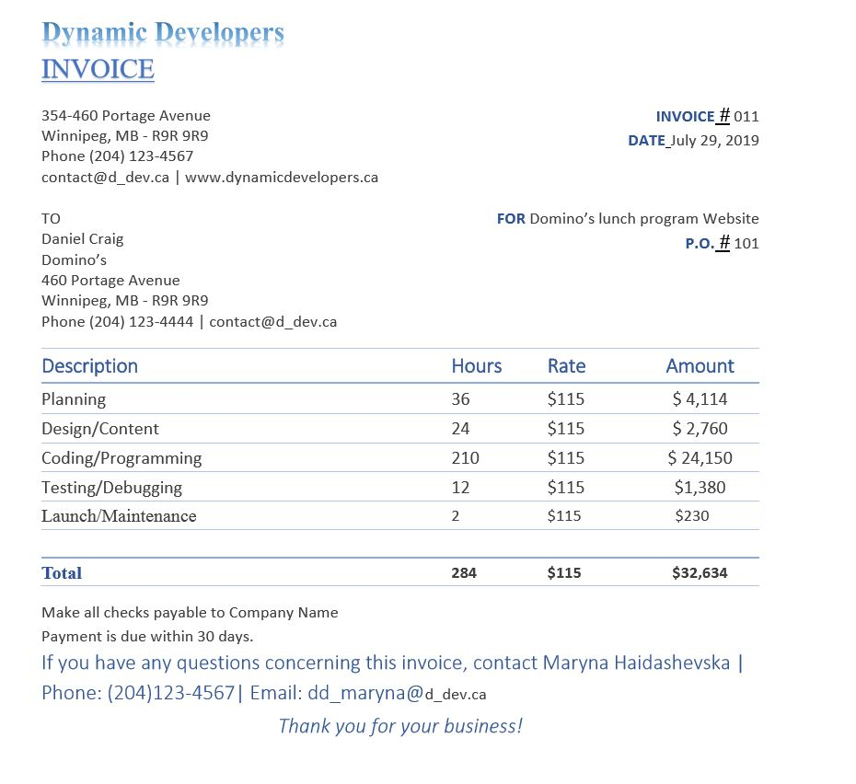

**Conceptual Model:**

Stores

Menu Items

Events

Setup

Orders

Calendars

Schools

m

m

m

m

1

1

1

1

Classrooms

1

m

m

Payments

m

1

Parents

**Conceptual Model –** School Lunch Planner

July 27, 2019

April 4, 2019

1

1

1

m

Order Items

m

1

Contacts

Students

Event Items

1

m

1

Provinces

1

1

m

m

1

m

**Logical Model:**

Stores

idstore(PK)

province(FK)

Menu Items

iditem(PK)

Events

idevent(PK)

idschool (FK)

Setup

Orders

idorder(PK)

idevent(FK)

idstudent(FK)

Calendars

idcalendar(PK)

Schools

idschool (PK)

province(FK)

idstore(FK)

m

m

m

m

1

1

1

1

Classrooms

idclassroom (PK)

idschool(FK)

1

m

m

Payments

idpayment(PK)

idorder(FK)

m

1

Parents

idparent(PK)

**Logical Model –** School Lunch Planner

July 27, 2019

April 4, 2019

1

1

1

m

Order Items

idorder(PK)

iditem(PK)

m

1

Contacts

idcontact (PK)

Students

idstudent(PK)

idparent(FK)

idclassroom(FK)

Event Items

idevent(PK)(FK)

iditem(PK)(FK)

1

m

1

Provinces

province(PK)

1

1

m

m

1

m

**Physical Model:**

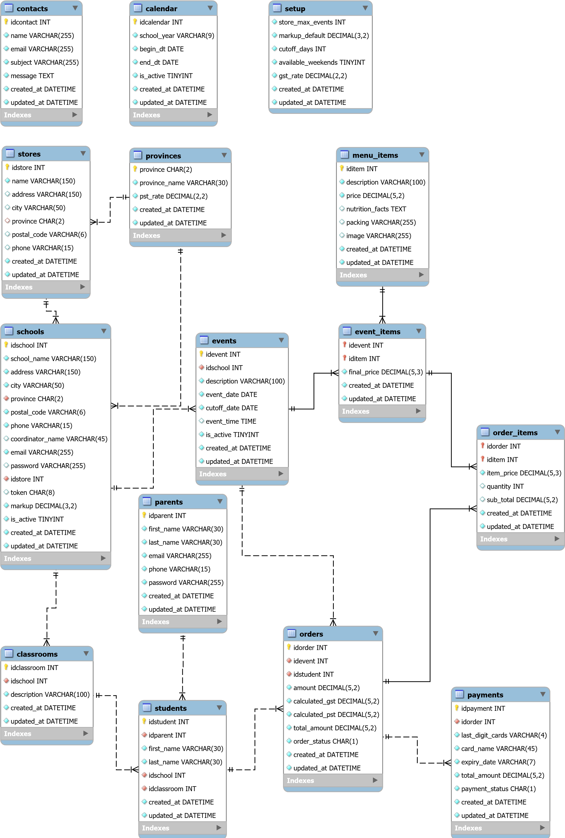

**Use Case Diagram:**

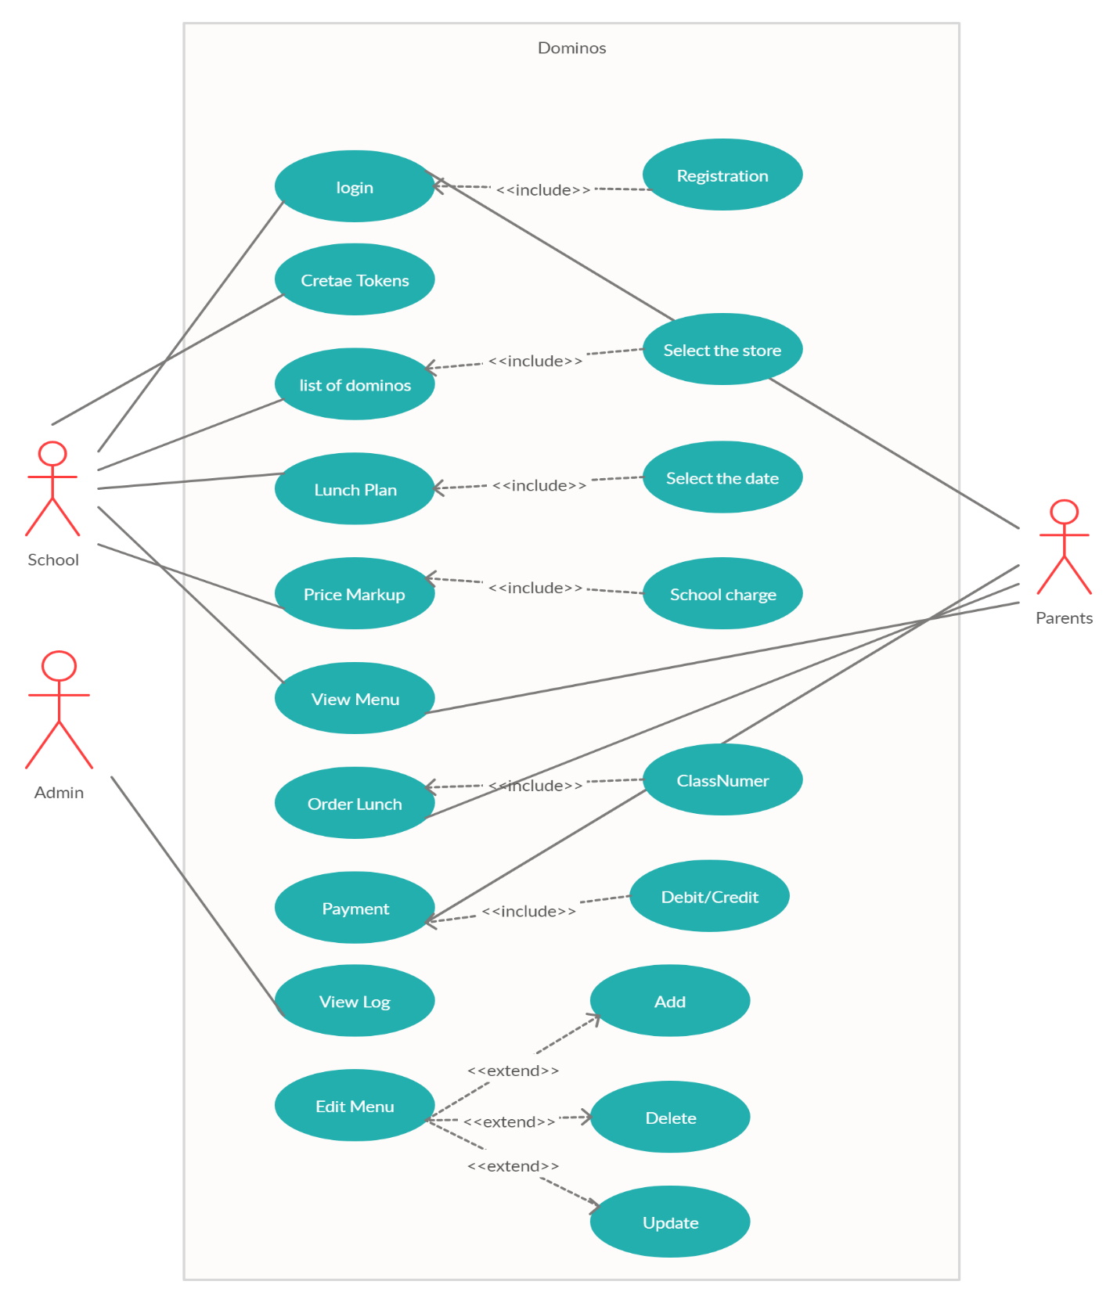

**Wireframe:**

Logo

Navigation

**Home Page**

**Hero Image and call to action for lunch order (go to registration page)**

**Shipping, call number and gift cards details**

Subscribe and footer

**Pizza Nutrition**

**Sign up call to action**

**Call to action for instruction**

Logo

Navigation

**Menu Selection Page (School)**

**Food 1**

Description / Cost

Quantity / Cost

Add

**Food 2**

Description / Cost

Quantity Selection

Image

Image

Subscribe and footer

Logo

Navigation

**Home Page (School)**

**Calendar**

**List of school’s events**

New Lunch Order

Subscribe and footer

Logo

Navigation

**Register Page**

**Full Name**

**School Name**

**Address**

**Contact Info**

Subscribe and footer

Logo

Navigation

**Create Students List**

**Student full name**

**Current Student list**

**Student ID**

**Class**

Edit

Upload csv file

Subscribe and footer

Logo

Navigation

**Create New Lunch**

**School ID (auto-created)**

**Date and time**

**School Name**

**School Address**

**Contact**

Subscribe and footer

Logo

Navigation

**Choose Menu**

**School contact details**

**Food list**

**Price for parents**

**Table of food list with cost and price**

**Comments for parents**

Subscribe and footer

Del

**Mock up Design:**

**Home Page**

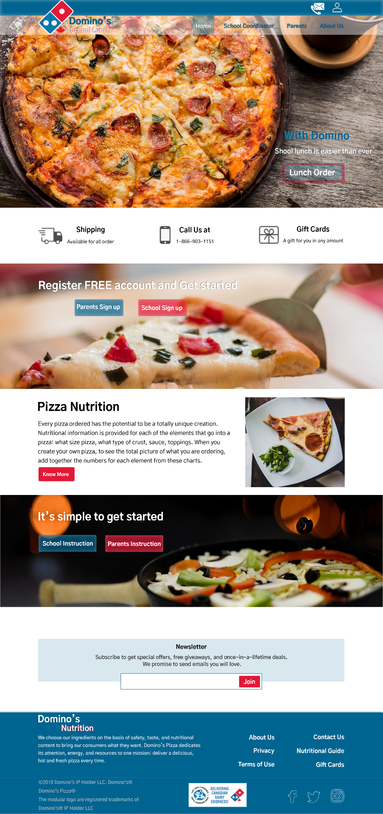

**Sign up Home Page**

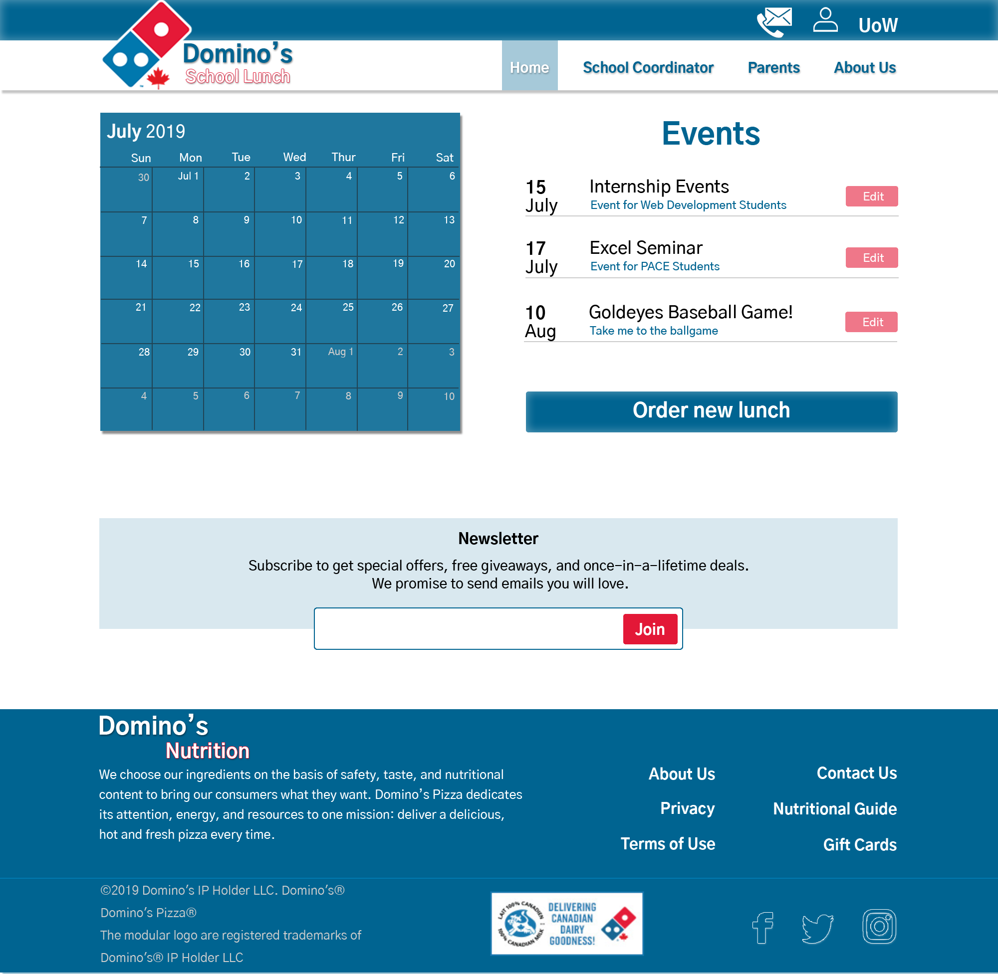

**About Us Page**

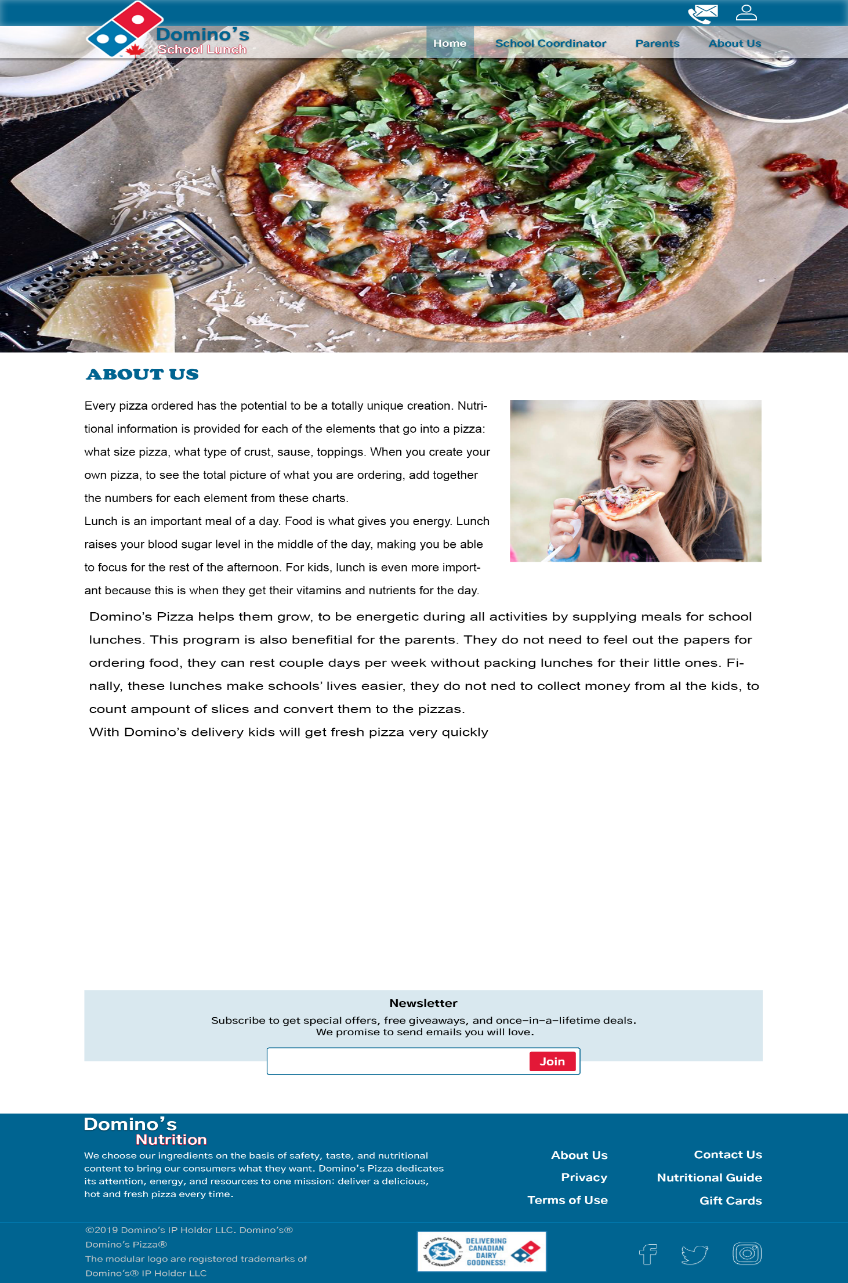

**Product List Page**

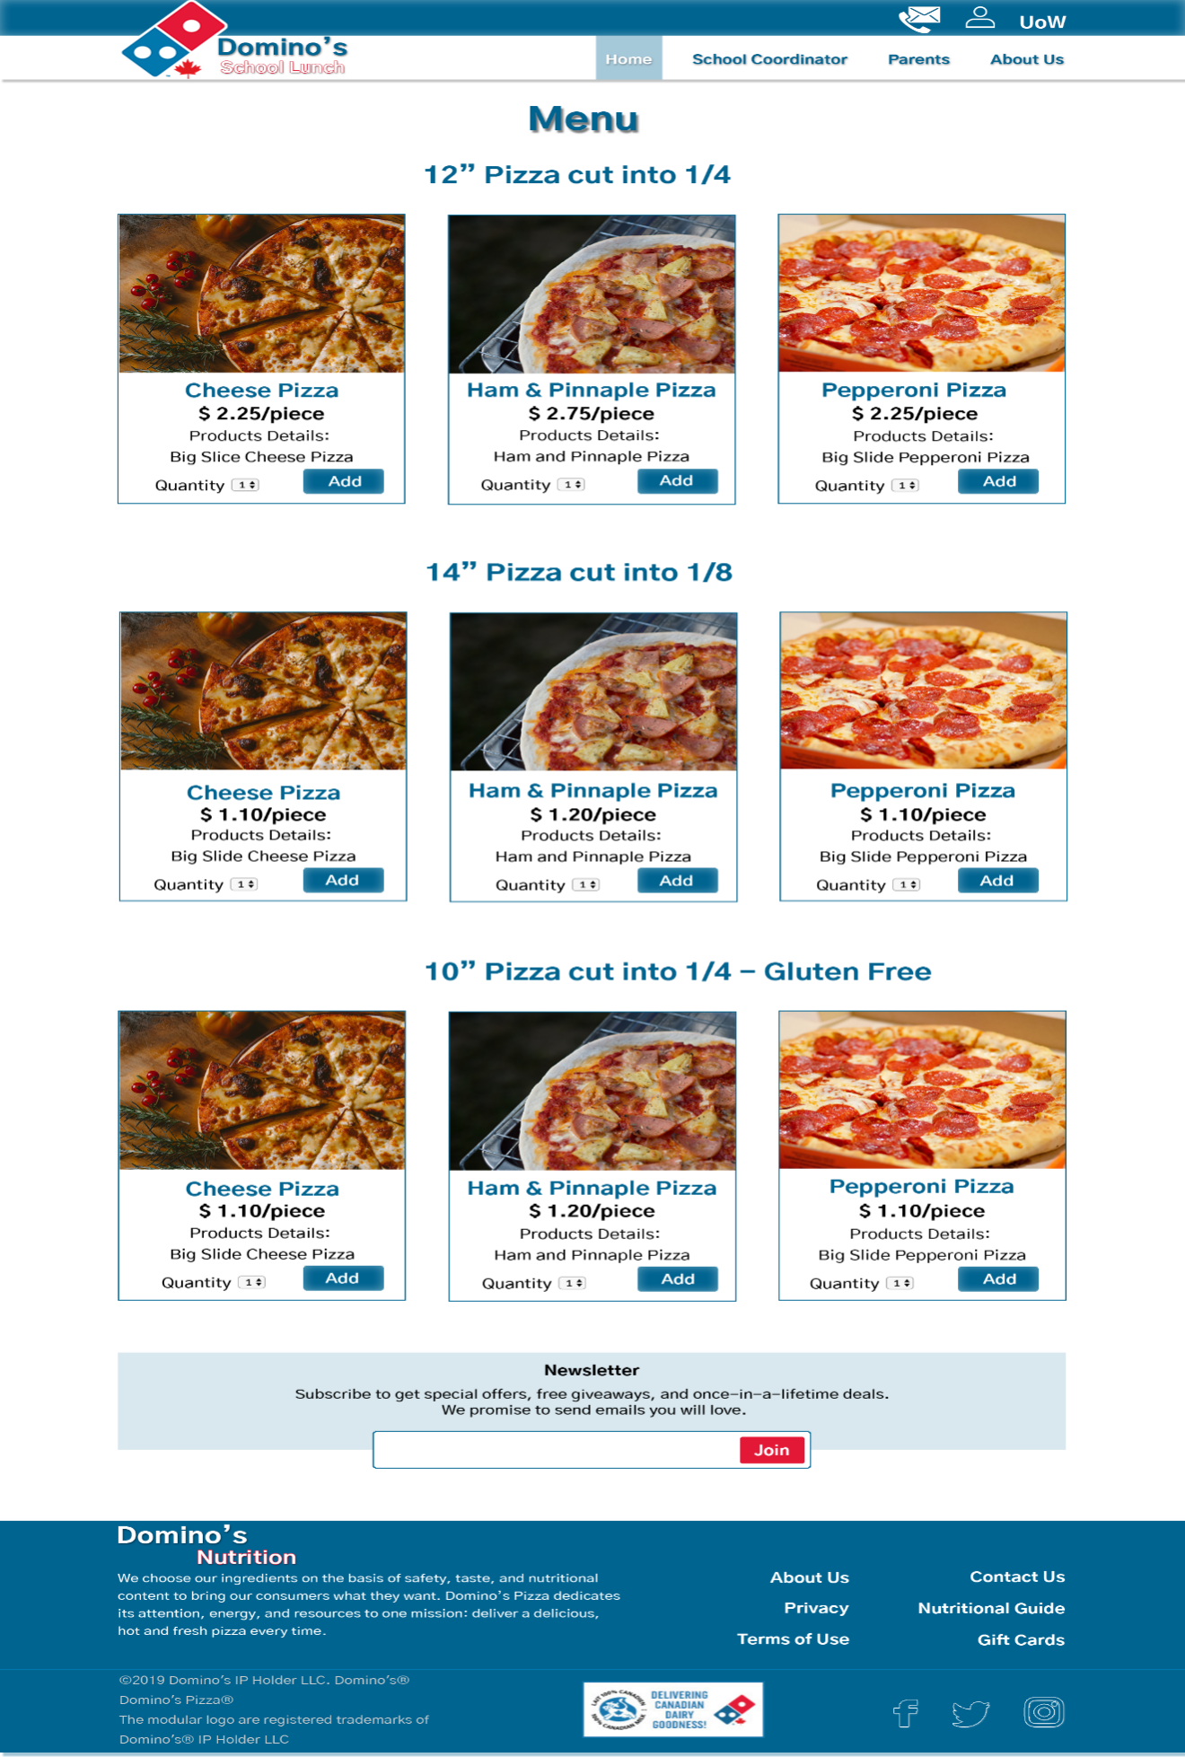

**Login Page** 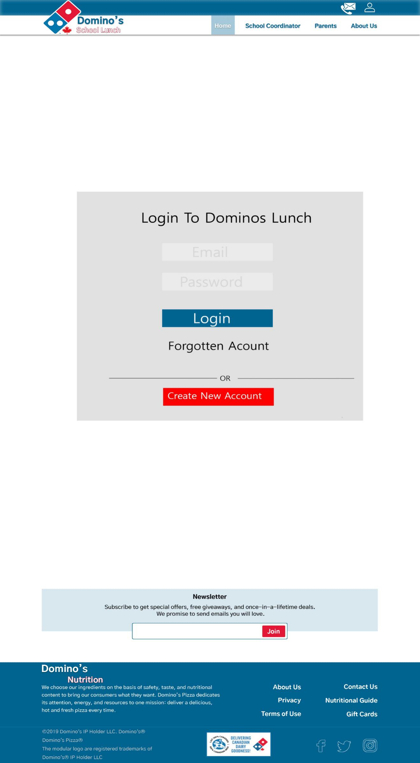

**Signup for Parents**

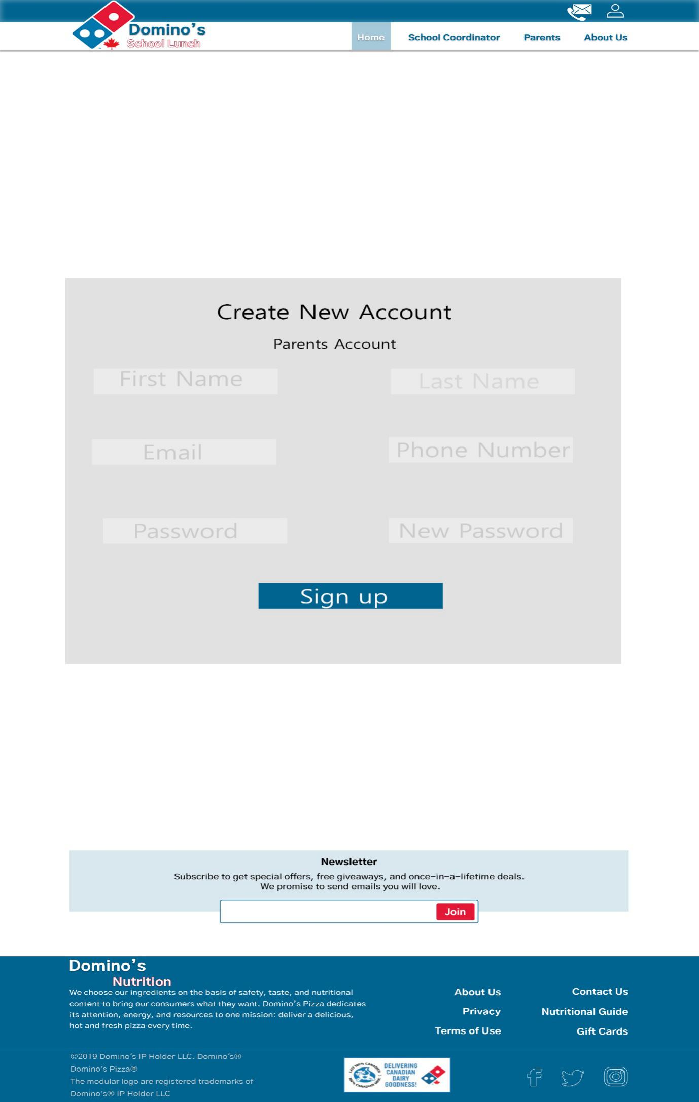

**Signup for School**

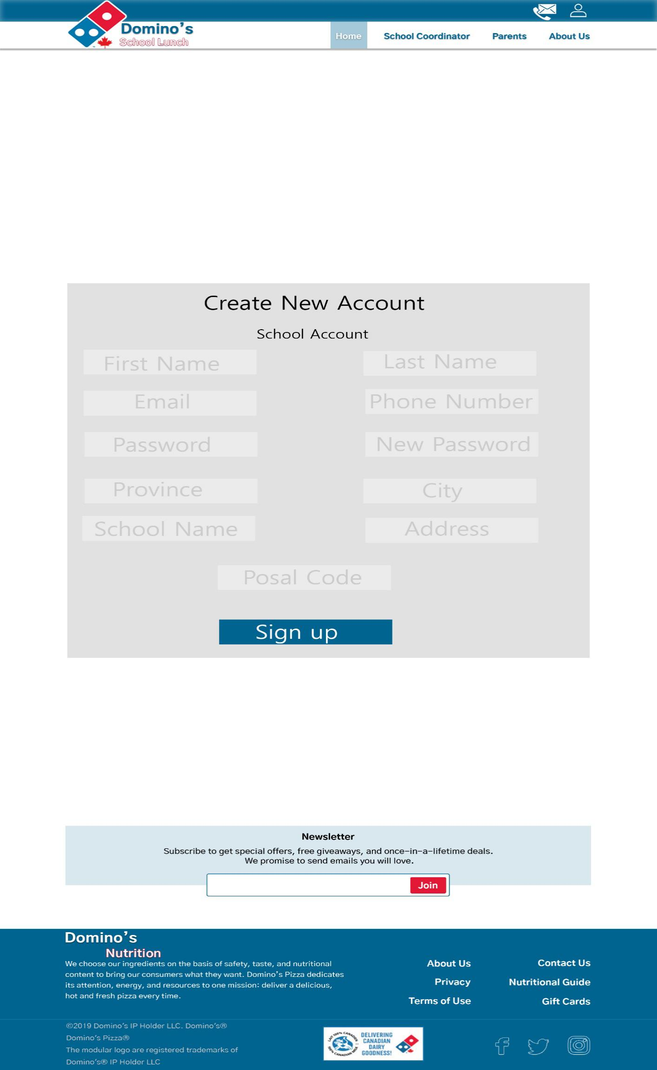

**Contact Us Page**

